13.75: Of the many ways to find the time interval, a convenient method is to take 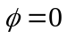 in Eq. (13.13) and find that for . The time interval available is from 